Data Structures

Stacks:

First in Last out

Last In First out

Application: Browser History. The most recent tab opened (last in ) will be on the top of the list (first out)

Queue

First In First Out

Last in Last Out

Application: Line up to buy a burger. The first person (first in) in line will be given the burger the first and can leave the line ( first out ).

Map:

Searching for a specific item in the array. Index search[ 0 ] = first value VS Map using string

In Map each index will have a specific name called the **Key**

Key : Value Pair

Array Cons:

Arrays cannot be expanded

Linked List – Effective use of Memory for storing data.

|  |  |
| --- | --- |
| Array | Linked List |
| Is not expandable | Is expandable |
| May result in wastage of memory | No Wastage of Memory |
| Inefficient Insertions and deletions | Efficient insertions and deletions |
| Random Access i.e efficient indexing | No Random access ( have to go through all element to get to specific element ) |
|  |  |

CS DOJO – Data Structures And Algorithms

Data Structures: Different ways of storing data

Algorithms = operations on data structures

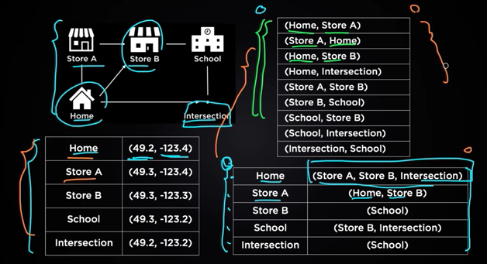

Top– Array List Data Structure method

Bottom - Hash Table And Hash Map

Storage of Array in Memory

Depending on the system / environment the memory is allocated as 32 bits or 64 bits

8 bits = 1 byte

An integer is stored as 32 bits ( 8bits * 4 ) = 4 bytes

If elements need to be added to an array a new Array must be created